How to use MySQL command line client ?

**Process-1:**

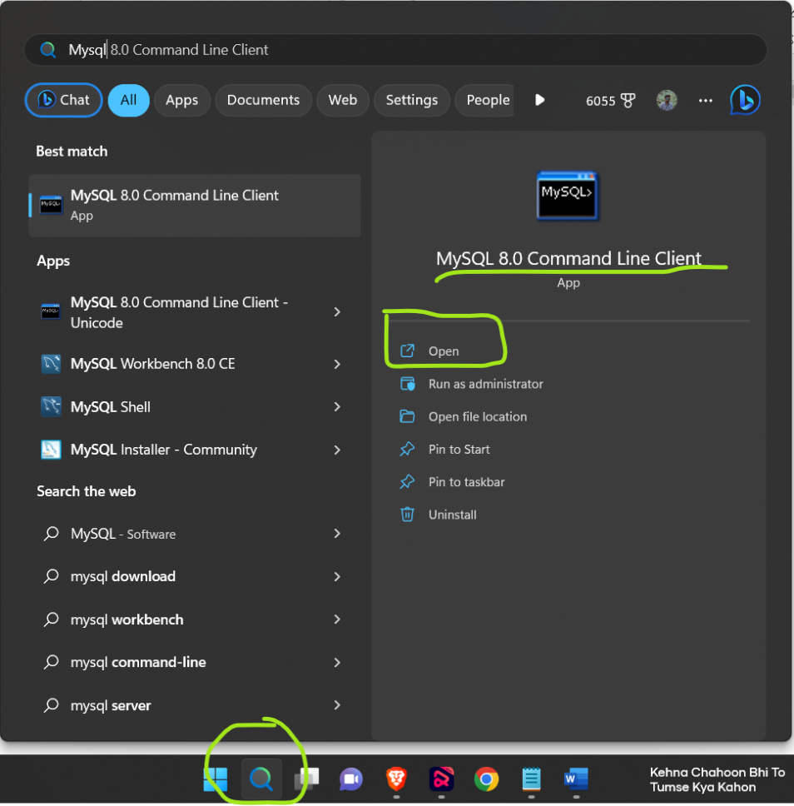Step-1: Search MySQL command line in search bar of your pc and click on open.

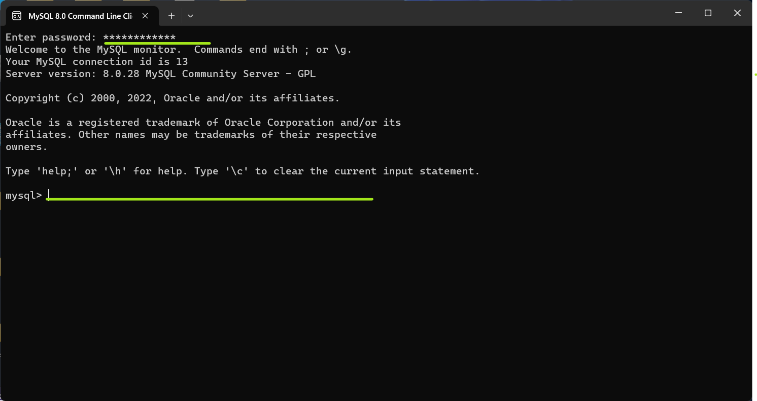Step-2: Then give your password and click on enter button and start writing your command.

**Process-2:**

Step-1: Open command prompt by type cmd in search button.

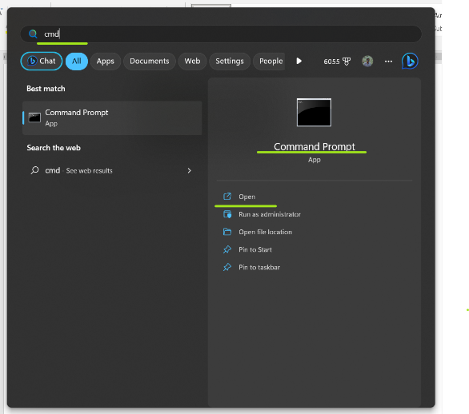

Step-2: Then run this command [ mysql -u root -p ] click enter and give your password.

